## 17IE4048 – PROJECT-1 PROJECT BASED REPORT ON

**HEART PULSE MONITORING AND NOTIFICATION SYSTEM USING**

**ARDUINO**

***submitted in partial fulfillment of the requirement for the award of the degree of***

## BACHELOR OF TECHNOLOGY

**In**

**COMPUTER SCIENCE AND ENGINEERING**

**By**

**HEMANTH SAI GOKARAKONDA (170030384) JASWANTH GODAVARTHI (170030477)**

**SIVA SAI KANNEGANTI (170030556) HARI KIRAN PENDURTHI (170031577)**

*Under the Esteemed Guidance of*

**Dr. S.KAVITHA *PhD***

***Assistant Professor***



## DEPARTMENT OF COMPUTER SCIENCE AND ENGINEERING

**K L (Deemed to be) University**

Green Fields, Vaddeswaram, Guntur District – 522 502

**DEPARTMENT OF CSE, KLEF**

1

## EXTERNAL EXAMINER

**K L (Deemed to be) University**

**DEPARTMENT OF COMPUTER SCIENCE AND ENGINEERING**



**DECLARATION**

This is certify that the project based report entitled **“HEART PULSE MONITORING AND NOTIFICATION SYSTEM USING ARDUINO”** is a bonafide work done and submitted by **Hemanth Sai Gokarakonda (170030384), Jaswanth Godavarthi (170030477), Siva Sai Kanneganti (170030556), Hari Kiran Pendurthi (170031577)** in partial fulfillment of the requirements for the award of the degree of **BACHELOR OF TECHNOLOGY** in Department of Computer Science Engineering, KL (Deemed to be University), Guntur District during the academic year **2020-2021**.

**HEMANTH SAI GOKARAKONDA (170030384) JASWANTH GODAVARTHI (170030477) SIVA SAI KANNEGANTI (170030556) HARI KIRAN PENDURTHI (170031577)**

**DEPARTMENT OF CSE, KLEF**

2

## (2020-2021)

**K L (Deemed to be) University**

**DEPARTMENT OF COMPUTER SCIENCE AND ENGINEERING**



**CERTIFICATE**

This is certify that the project based report entitled **“HEART PULSE MONITORING AND NOTIFICATION SYSTEM USING ARDUINO”** is a bonafide work done and submitted by **Hemanth Sai Gokarakonda (170030384), Jaswanth Godavarthi (170030477), Siva Sai Kanneganti (170030556), Hari Kiran Pendurthi (170031577)** in partial fulfillment of the requirements for the award of the degree of **BACHELOR OF TECHNOLOGY** in Department of Computer Science Engineering, KL (Deemed to be University), Guntur District during the academic year **2020-2021**.

**Dr. S.KAVITHA Mr. V. HARI KIRAN**

**FACULTY INCHARGE HEAD OF THE DEPARTMENT**

DEPARTMENT OF CSE DEPARTMENT OF CSE

K L (Deemed to be University) K L (Deemed to be University)

**DEPARTMENT OF CSE, KLEF**

3

# ACKNOWLEDGEMENT

The success in this project would not have been possible but for the timely help and guidance rendered by many people. Our sincere thanks to all those who has assisted us in one way or the other for the completion of my project.

Our greatest appreciation to our guide **Dr. S.KAVITHA**, Assistant Professor, Department of Computer Science and Engineering which cannot be expressed in words for her tremendous support, encouragement and guidance for this project.

We express our gratitude to **Mr. V. Hari Kiran,** Head of the Department for Computer Science and Engineering for providing us with adequate facilities, ways and means by which we are able to complete this project.

We thank all the members of teaching and non-teaching staff members, and also who have assisted me directly or indirectly for successful completion of this project.

Finally, We sincerely thank my friends and classmates for their kind help and co- operation during our work.

**HEMANTH SAI GOKARAKONDA (170030384) JASWANTH GODAVARTHI (170030477) SIVA SAI KANNEGANTI (170030556) HARI KIRAN PENDURTHI (170031577)**

**DEPARTMENT OF CSE, KLEF**

4

# ABSTRACT

The main aim of our project is to provide an automated system to detect and notify the heart pulse of a patient and if there’s any abnormality in the pulse, then it should send the

notification to the concerned person or doctor through SMS. Since it is automated, there’s no need for human interaction in between the process. The automation which we have provided is by sending the notifications through online API Twilio. We have used a pulse Sensor to detect the heart pulse and an Arduino UNO board for the interface and Bolt Wi-Fi module which collects the data and sends it to bolt cloud and AWS will retrieve the data from bolt cloud. Later we have also used the SMS API service (Twilio) to send SMS regarding the abnormality of concerned patients. In this way, we are providing a solution to remotely access the heart pulse data of the patients and doctors are benefited the most by our project.

**DEPARTMENT OF CSE, KLEF**

5

# CONTENTS

|  |  |  |
| --- | --- | --- |
| **Chapter No.** | **Title** | **Page No.** |
| 1 | INTRODUCTION | 7-8 |
| 2 | LITERATURE SURVEY | 9-19 |
| 3 | COMPONENETS REQUIRED | 20-22 |
| 4 | EXPERIMENTAL INVESTIGATIONS | 23-24 |
| 5 | BLOCK DIAGRAM AND FLOW DIAGRAM | 25-28 |
| 6 | IMPLEMENTATION | 29-42 |
| 7 | EXPERIMENTAL RESULTS | 43-44 |
| 8 | DISCUSSION OF RESULTS | 45-46 |
| 9 | CONCLUSION | 47 |
| 10 | USER STORIES, MOTIVATION AND FUTURE  SCOPE | 48 |
| 11 | REFERENCES | 49-50 |

**DEPARTMENT OF CSE, KLEF**

6

# INTRODUCTION

This covid-19 pandemic has caused many problems to everyone and especially the most

affected ones are the patients. Patients whose heart pulse needs to be monitored regularly by the concerned doctors are affected by this Covid-19 outbreak. There has been a communication gap formed between these patients their concerned doctors/caretakers. Due to the implementation of lockdown all over the world the situation got worse for the patients. [1] This is where our idea flourished to help those section of patients whose heart pulse needs to be monitored regularly. [6] With the help of the knowledge, we gained from the concepts of IOT and its applications in medical field, we have researched and studied many research papers related to our problem statement. After reviewing many papers, finally we have chosen one paper, as our base paper and started working on the idea. Our project “Heart Pulse Detection and Notification System using Arduino” mainly focuses on the communication gap between the patients and their doctors. The main aim of our project is to establish a communication bridge between the patients and the concerned caretakers/Doctors. [5] We have used reliable components such as Arduino Uno, which is the brains of the system, heart pulse sensor, which detects the heart pulse of the body, and BOLT Wi-Fi module for establishing a connection to send data through internet.

We have used the most reliable VPS service provider which is AWS VPS to run the program(code) required to detect the abnormality present in the heart pulse. For the

notification module, we have used TWILIO as our online API service which sends data to the concerned doctor whenever there is an abnormality present in the patient’s heart pulse.

We have implemented the following technologies in out project:

1. **IOT** – IOT stands for Internet of Things. IOT describes the network of physical things that are embedded with sensors, actuators, software, ETC for connecting and exchanging data with other devices in a network via internet.[2] The applications of IOT are divided into 4 types they are of 4 types they are consumer, commercial, industrial, infrastructure. In the consumer market IOT is mainly used with the products pertaining to home automation or smart home systems. IOT can also be applied to healthcare systems this type is known as H-IOT. In our project we have used the H-IOT concept to create a healthcare system which monitors and notifies the doctors about the patient’s heartbeat whenever there is an abnormality. But there are several privacy and security concerns regarding growth of IOT.
2. **H-IOT** – H-IOT stands for healthcare IOT. This is undoubtedly transforming healthcare industry by delivering healthcare IOT solutions.[10] These implementation benefits patients, hospitals, companies.
   * **IOT for Patients** - IOT devices in the form of fitness bands, smart bands give us various data about the patients. These features can be turned on and off according to the requirement of the user. IOT has changed people’s life’s especially elderly patients by monitoring various aspects of the patients continuously.
   * **IOT for Hospitals** –[9] Apart from checking patients health details continuously there are many more advantages of IOT in hospitals. The IOT devices are very useful for tacking medical equipment like wheelchairs, oxygen pumps, and monitoring equipment. Hygiene is also important with the help of IOT devices spread of infectious diseases. IOT can also be used in asset management like environment monitoring, pharmacy inventory control, humidity, and temperature control, etc.

**DEPARTMENT OF CSE, KLEF**

7

* + **IOT for Insurance Company’s** – There are many opportunities for health insurers with IOT connected intelligent devices. Insurance companies can use the data which is captured through health monitoring devices for underwriting and claims operations.

This project Heartrate monitoring and notification system using Arduino con be useful in IOT for Patients and for Hospitals for monitoring patient’s heartbeat always.

1. **CLOUD COMPUTING** – Cloud Computing refers to providing on demand availability of Computing resources epically data storage and computing power without any direct management by user.[3] This term is used to define datacentres available to many users over the internet. The clouds may be limited to only one organization or to multiple organizations. The cloud providers generally use Pay as you go scheme.[4] We have selected Aws as our cloud because it has a variety of

features and follows a pay as you go scheme the cost of using the cloud is limited and with the limited cost we also get a plethora of features to be used in the project which is deployed in AWS server.

1. **USAGE OF API’S** – API stands for Application Programming Interface. This allows to applications to communicate with each other. One of the main requirements of this project to send SMS whenever there is an abnormality so in this case, we use a SMS API service called Twilio. Whenever there is an abnormality detected in the AWS server with the help of a program, we can access Twilio and send SMS about the status of the patient.

**DEPARTMENT OF CSE, KLEF**

8

# LITERATURE SURVEY

## Low Cost Heart Rate Portable Device for Risk Patients with IOT and Warning System

**Muhammad Irman, Era Madon**

In this paper it is designed with a less price of compact device to heart rate monitoring for threat patients with internet of Things based and short message service notification as a warning system. Wi-Fi module has a function to communicate the web server gateway and pulse sensor. The Wi-Fi module has function to interface with a web server gateway and a heart pulse sensor. Patients and doctors can see heart rate information through the website in real-time. The patient heart rate is below 60bpm and greater than 100 bpm and the patient having the emergency button. The heart pulse sensor is rate which it is converted into the bit per minute. The data is saved using the transmission control protocol and internet protocol communications. The data which can be seen by the doctors and patients through the website in the real time applications. The warning system will send the message to the doctors by using the TCP IP communications. The heart rate is displayed in a screen which the screen is connected to the breadboard. And the heart rate is also displayed on the website portal and can see the information at any time on the website.so that if the patient having an emergency problem there is a emergency button which is used for the patient’s emergency to go the hospital.

**DEPARTMENT OF CSE, KLEF**

9

## Smart Health Care Monitoring Using IOT Shubham Banka, Isha Madan, S.S.Saranya

IOT plays a crucial role in health care providing better medical facilities to patients and doctors and for hospitals remotely without any human interaction. The proposed outcome of this paper is to build a medical system that helps to patients who don’t have hospitals in their areas and they can access our system remotely here the raspberry pi micro controller collects the data of the patients remotely via internet and gathers the health reports of the patients. This system also measures the heart pulse and blood pressure and it will send the collected information of patient’s health to their family members and doctors so they can keep monitoring the patients’ health status and full medical information remotely in case of any medical emergencies the collected information of the patients health data can be analyzed and predict disorders such as heart attack in preliminary stage itself using the data of patients health status and here we proposed an automatic system to monitor the patient’s body temperature, heart rate, body movements and blood pressure remotely. The sensors that are placed on the patient’s body measures and takes the readings of the patient and will send the collected data and signal to raspberry pi. The Raspberry Pi is a credit card-sized single-board computer which is operated on Linux software and all the sensor measures the reading and sends the data via raspberry pi to consultant doctor and patient remotely without any third person interaction.

**DEPARTMENT OF CSE, KLEF**

10

## A smart system for remote monitoring of patients and SMS messaging upon critical condition

**Angad Kale, Siddharth.K. Kaul, Debi Prasad Das and S. Raghunath**

This paper proposes a smart system which will monitor the patient’s condition and health status in the hospital and if there is any abnormality in patient it will immediately send an SMS message to the patients mobile phone upon his abnormality of his health. This system can be used to monitor various patient’s health status and their conditions in hospitals. This system consist of supervisory computer, Wi-Fi module and detailed data of the patient’s kept near the patient’s bed and it will monitor the patient’s accurately if there is any abnormality or critical condition of the particular patient it will send the concerned data to the doctor, nurse through the GSM messaging module to alert the situation of the patient and one of the serial ports near patient’s bed will have TTL interface as it is connected to the F-bus and to any mobile phone. And any GSM modems can also be used in place of normal cell phones and the advanced technologies and data used here are ZigBee, RS485, GSM and it also involves a server computer and microcontroller here it collects the data from the various sensors like body temperature sensor, ECG sensor and body pressure sensor and it collects and measures the data of the patient and if there is any disorder or critical condition of the patient it will alert the doctor and patient through an SMS message which is sent by using GSM module. This system is very useful in hospitals where patients locates far away from hospital areas can be able to contact the doctor or notified easily by this system.

**DEPARTMENT OF CSE, KLEF**

11

## Development of Smart Healthcare Monitoring System in IOT Environment Md. Milon Islam Ashikur Rahaman, Md. Rashedul Islam

IOT plays an crucial role in health care providing better medical facilities to patients and doctors and for hospitals remotely without any human interaction and health care monitoring systems in hospitals and many other health care hospital and health centers as they have experienced a huge growth in monitoring systems. IOT produces the progress health care monitoring system from face to face consultancy to telemedicine.

This paper proposes a smart health care monitoring system using IOT which monitors the patient’s health status and store the data and sends the data to doctor so they can check the data accurately and responds to the critical condition of the patient. In this system we used five sensors that are heartbeat sensor, body temperature sensor, room temperature sensor, co sensor and co2 sensor all these various sensors are used to capture the patient’s data. If there is any critical condition of the patient it conveys the data via a portal to hospital and medical staff where they can monitor the patient and check their health status and current situation of the patient and the collected data are sent via an ESP32 module and it will send the data to a gateway server. Thing Speak is used for graphical interpretation and will display the all collected data and it shows the current status and process of transaction and the HTTP protocol provides easy response between Wi-Fi module and web server by this way we send the information through internet.

**DEPARTMENT OF CSE, KLEF**

12

## Heartbeat and Temperature Monitoring System for remote patients using Arduino

**Ruaa Shallal, Abbas Anooz**

This paper describes the working of IOT in a wireless heartbeat and temperature monitoring system and considering a microcontroller (Arduino uno). Most of the monitoring systems that are used in today’s world works in offline mode and we can design it in such a way that it measures the patient’s data remotely in real time. This method consists of sensors which are used to measure the heartbeat and temperature of a patient and measure the readings and send the data to consultant doctor and patient which is controlled by microcontroller. Both the readings are measured and displayed in an LCD screen. Wireless system which is used to monitor and transmit the measured data from remote location. The heartbeat sensor measures the heartbeat for specific time and will estimates beats for minute while the temperature sensor measures the temperature of the patient’s body and both these readings send to the microcontroller for transmission to receiver end. Finally, this data will be displayed in an LCD screen and this system will be available in less cost with great effect. The various sensors Arduino ATmega328, Temperature sensor LM35, Heart Beat Sensor LM358, nRF24L01 Module and an LCD display with a power supply these measure the data and send the data to microcontroller which will monitor and display the result on an LCD monitor accurately .

**DEPARTMENT OF CSE, KLEF**

13

## Developing IoT Based Smart Health Monitoring Systems Ashikur Rahaman, Muhammad Sheikh Sadi, Sheikh Nooruddin

IOT based health care monitoring system is a smart care monitoring system where patients can be monitored 24 hours remotely. IOT plays a crucial role in health care providing better medical facilities to patients and doctors and for hospitals remotely without any human interaction. Health care monitoring systems in health care hospital and health centers have experienced a huge growth in monitoring systems and it is also changing the infrastructure of the existing technologies. There are many types of projects created to monitor the patient’s health remotely. This paper proposes a smart health care monitoring system using IOT which monitors the patient’s health status and store the data and sends the data to doctor so they can check the data accurately and responds to the critical condition of the patient. Here we use different sensors to collect the data from patient’s body such as ECG sensor, pulse rate detecting sensor, temperature sensor, respiration sensor, RFID sensor, gluco-meter sensor, body position sensor and co2 sensor. All these various sensor collects the patient’s data and send the data to microcontroller and these data which is collected is stored in a cloud and via using the help of internet and some third parties API’s this data will be sent to doctors and health care organizations and this received data of a particular patient will be monitored by doctors and hospitals as they can monitor the patients health status 24 hours accurately and take safety measures before any critical situation occurs. In this way IOT play a huge role in medical and health care organizations.

**DEPARTMENT OF CSE, KLEF**

14

## Continuous Heart Rate and Body Temperature Monitoring System using Arduino UNO and Android Device

**Asaduzzaman Miah, Hussain Kabir,Siddiqur Rahman Tanveer ,M.A.H. Akhand**

An integrated portable device for continuous heart rate and body temperature monitoring is presented in this paper. Cardiovascular diseases are increasing day by day; therefore, accurate, inexpensive and portable heart rate and body temperature are essential for taking timely action. Such a device is especially important in a situation where there is no doctor or clinic nearby (e.g., rural area) and patients are unable to see their true condition. The enhanced version of this tutorial contains the Arduino UNO microcontroller system, transfer system and Android-based application. The app provides simultaneous heart rate and temperature information obtained from a mobile device in real time and displays it via an instantly connected Android app. The upgraded system is more expensive at a lower price compared to other advanced devices due to using the available Arduino UNO and smart phone as an Android device. The improved device is shown acceptable results compared to other measurement devices.

**DEPARTMENT OF CSE, KLEF**

15

## Analysis of Heart Rate and Body Temperature from the Wireless Monitoring System Using Arduino

**Mohammad Dabbagh**

The state of the Intensive Care Unit (ICU) ward tends to be much larger since ward patients are often critically ill patients. These patients need them intensive care by nurses and doctors because their condition is not very stable.

Therefore, nurses and doctors need to monitor them frequently. So, the idea of this the monitoring system primarily reduces the workload of nurses by reducing the

frequency of monitoring. This a carefully designed monitoring system to make them aware of their patient that way, they can reducing the risk of patients being treated. This monitoring system uses microcontroller (Arduino Uno) connected to laptop via Bluetooth to transmit defendant heart rate and body temperature data. This data made sense with the Heart Rate Grove sensor and the LM35 temperature sensor. Details processed and displayed a full-time laptop continuously. A different color LED was used as a reference in inform the respondent's heart rate or body temperature whether it was high or low status as a warning. In a young adult who has a fever, it shows an effect of 81 bpm of heart rate and 37.63oC body temperature by 3.83% and 0.65% Mean Absolute Percentage Error (MAPE) respectively. This monitoring system has been successfully developed and has been able to show the defendant's heart rate and body temperature data every minute as well able to perform independent surveillance tasks in the future.

**DEPARTMENT OF CSE, KLEF**

16

## Web-based remote monitoring of infant incubators in the ICU

**D.I. Shina, S.J. Huha, T.S. Lee , I.Y. Kimc**

A real-time web-based system, management, and monitoring to test the temperature and humidity inside infants using the Intranet was developed and incorporated into the Department of Infant Care (ICU). We have created a sensing system with temperature and humidity sensors and measuring module in each incubator, connected to the web- server board via RS485 the harbor. The system transmits signals using standard TCP / IP web for users access the system on any personal computer connected to the Internet at the hospital. Using this method, the system collects heat and humidity data that is transmitted from the RS485 port measurement modules on the web server board and creates a web document containing this data. The system manager may end up in one place monitor the oversight of conditions in all conjunctions while sitting inside the baby The ICU in the work space is equipped with a personal computer. The program can be set to monitoring unusual situations and sounding an alarm signal heard as a sound or light in the measurement module connected to a related incubator. If the system arranged with a large number of incubators connected to a single control a monitoring station, will improve ease of use and ensure meaningful development responding to events that require intervention.

**DEPARTMENT OF CSE, KLEF**

17

## Applying Telecommunication Technology to Health James C. Lin

Telemedicine is ready to provide care for disadvantaged communities e areas of diagnosis and management of difficult conditions and screening of patients in remote areas. Provides great potential benefits to patients also enhances the skills of local doctors. It is an effective method to provide basic professional consultation

in the remote emergency department. By reducing the need for hard transfers on

high hospital, great benefits can expected. Although the conclusions of all the subjects updated to recommend the use of telemedicine, the currently available evidence is not enough to suggest its widespread implementation. Extras studies are needed to determine when and when with which parties and conditions telemedicine is an

effective delivery method medical services, and if so cost effective. As wide and wide of telemedicine applications increasing, there are several technical and clinical problems that require intensive research. In any case, it seems deploy telemedicine on a broad basis of poorly served communities, where possible be the only logical way.

**DEPARTMENT OF CSE, KLEF**

18

## An IOT-Based smart framework for human heartbeat rate monitoring and control system

**Dr. Maria, Liz Crespo**

This research paper outlines the design and implementation of Internet of Things (IoT) a framework based on a program to monitor and control a person's heartbeat. Complete studying the various techniques and techniques used to control heart rate checked. The proposed system was developed and used on a variety of food boards integrated, connected, and tasting parts of the system. Test results obtained from the type used was found to be accurate, as the system was able to hear and read

its heart rate for its user and transmits sound information over the internet. Parts of the system they were sold on a loaf of bread and placed in a plastic container with a heartbeat extended, to cut the tip of a system user finger. Test results show

that the heart rate of children under 17 is between 65 to 115 beats per minute (BPM) and heart rate for an adult between the ages of 17 to 60 is 60 to 100 BPM. In in addition, the heart rate of adults 60 years and older, their heart rate the average is between 65 and 120 BPM respectively. These findings are in line with the national government in the field of medicine. In addition, this research paper, presents a

flexible approach is reliable, and is the secret of the heart rate monitoring and control system using the sensor network and IoT technology that can be disseminated in the medical field to assist medical personnel they do their job easily.

**DEPARTMENT OF CSE, KLEF**

19

# COMPONENTS REQUIRED

As one of the aim of this project is to provide the implementation at low cost we tried to complete the project using minimal but rather very much effective components. The components which we used are:

## Arduino Uno Board:

Arduino Uno Board is an open-source microcontroller board based on ATmega328P microcontroller which is developed by Arduino. The Arduino Uno board contains a set of pins which are used for input/output purposes. There are 14 digital I/O pins and 6 analog I/O pins. This board can be programmed by using Arduino IDE by connecting the Arduino to a laptop by using a Type B USB cable or an external power source.

## Pulse Sensor:

Pulse Sensor(Fig.2.2) is a plug and play device which is designed to work with Arduino for calculating the heartrate of a patient.[11] There are two surfaces and three

20

**DEPARTMENT OF CSE, KLEF**

pins to the sensor one side contains the LED and ambient light sensor on the other surface we have a circuit board containing noise cancellation and amplification. The three pins are ground, VCC(power supply), signal. When we place the sensor on our fingertip the sensor detects the vein which is present in the finger and whenever there is a blood flow change in the veins, we can calculate the heartbeat as well.

## Bolt IOT Wi-Fi module:

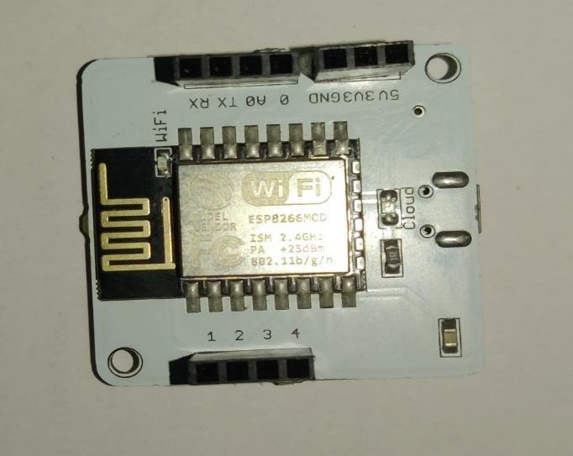

This Wi-Fi module acts as an interface to connect the hardware components to the cloud. This bolt Wi-Fi module is secure and fast. Here there are a few I/O pins which can used according to the user’s requirements. There are two lights present which indicate the working of the module. Green light indicates that the module is connected to cloud and orange light indicates that the Wi-Fi is on.

## Jumper Cables:

In this project we use M-M, M-F jumper cables which are used to connect various components to the Arduino Uno board.

**DEPARTMENT OF CSE, KLEF**

21

## Breadboard:

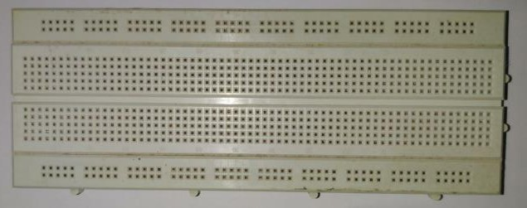

This breadboard is an extension which can be used to connect various components together. Instead of connecting by using soldering we can temporarily connect the components using a breadboard.

**DEPARTMENT OF CSE, KLEF**

22

# EXPERIMENTAL INVESTIGATIONS

## EXISTING MODEL:

We as a team have referred a lot of research papers and finally considered 12 papers as our main reference papers for our project. Out of which, we have taken one paper as our base paper which is “Remote Patients Monitoring System (Heartbeat and Temperature) using Arduino”. From the base paper, we have understood that they have implemented the concept of IOT in the medical field. They have used body temperature sensor which is “MLX90614” to detect the temperature of the body (person) and Heartbeat sensor to detect the heart pulse of the person. These two sensors come under the data sensor module of the tele-health monitoring system. The information in this module is then collected and sent to the data processing unit of the system. Here it analyses and sends the data to the data communication unit. In this unit, they have used LCD and given a power supply to it. Using this LCD as the output unit, they have provided the detected results of heart pulse and the temperature of the body.

## Disadvantages:

* 1. It is not automated.
  2. There is no notification system to this project i.e. there is no means of communicating the results remotely.
  3. Data is not stored i.e. there is no scope for the previous records to store in the system.

## PROPOSED MODEL:

We have taken these factors and tried to eliminate them. Our project “Heart pulse monitoring and notification system using Arduino” mainly concentrates on the communication gap between the patient and the concerned doctor. We tried to reduce the gap between them by introducing the concept of notification system to the already proposed model. For this purpose, with the help of the knowledge we gained from the IOT course, we have used TWILIO as our online SMS service to send notification regarding the heart pulse of the patient. We have used the similar sensor to detect the heart pulse of the patients which is the heart pulse sensor. We have used Arduino UNO as our main microcontroller of our project. Using a BOLT WIFI module, we have automated our system by establishing a connection with the internet through this module. Later we have used AWS VPS services to run our system and to that the notification system is attached. Our system checks for abnormality

**DEPARTMENT OF CSE, KLEF**

23

present in the heart pulse of the patient and if there is any abnormality observed then our system sends the message to concerned doctor in the form of SMS.

## Advantages:

1. Our project is fully automated.
2. Our project has a notification system which sends the message to the concerned doctor/person regarding the abnormality.
3. Since it has VPS service such as AWS and API service such as TWILIO, the previous data records are stored in the cloud. So that the doctor can review them later in the future.
4. Our system is cost efficient. We have tried to minimise the cost of our system as much as possible.
5. Since we have used online API service, there is no need of additional usage of GSM (sim) in our system to send message.
6. We have used AWS Virtual Private Server which is very reliable in market.
7. Our project is user friendly.

We have gathered, studied, understood, and then found the loopholes in our base paper. We have tried to reduce those loopholes as much as possible by improvising the idea and implementing the whole system automatedly.

**DEPARTMENT OF CSE, KLEF**

24

# BLOCK DIAGRAM AND FLOW CHART

## BLOCK DIAGRAM:

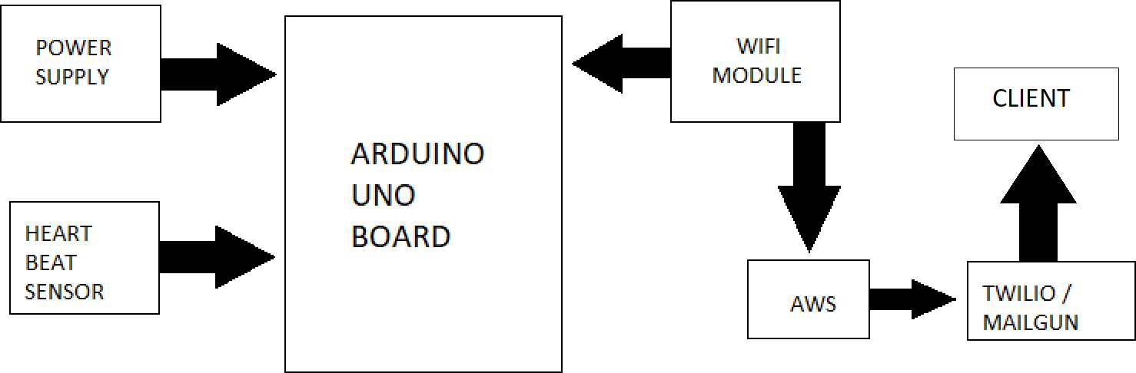

The block diagram consists of all the connections which are made in the execution of the project. Here basically we use a pulse sensor which has 3 pins VCC, Ground, Data these three pins are connected to the Arduino Uno board with the help of Jumper cables. The VCC is connected to the 5v pin of the Arduino Uno, the ground to ground and the data to Analog pin 1. After this connection the BOLT Wi-Fi module is connected to the Arduino Uno board with its respective pins ie (Tx and Rx of Wi-Fi module to Rx and Tx of Arduino respectively also the VCC is connected to the 3.5V of Arduino) . The hardware connections are done.

From here on the data from the Wi-Fi module is used in AWS and from AWS if there is any abnormality, we use Twilio to send SMS to the client.

**DEPARTMENT OF CSE, KLEF**

25

## FLOW CHART:

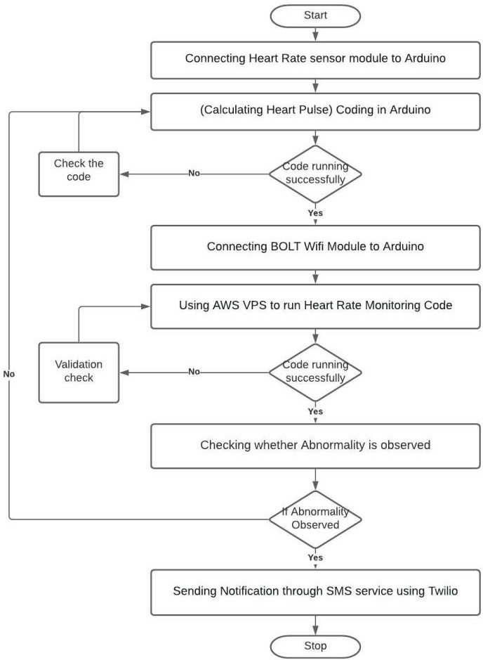

We have divided our project into 6 steps, 4 modules, and planned accordingly.

## Step-1: Connecting the Heart Rate sensor module to Arduino

We have gathered the necessary information, components, and done proper research regarding our process. We Arduino software in our system before connecting the Arduino UNO. Later we have taken a heart rate sensor which is used to calculate the heart rate of a patient. Using the three pins of the sensor, it is connected to the Arduino UNO. After connecting successfully, the system is now ready Step-2 of our project.

## In detail explanation about the working of the heart rate sensor:

The heart rate system contains a diode and a photodiode. Whenever we place our finger on the sensor, there will be a disturbance caused by the flow of the light emitted by the diode.

This disturbance is caused by the flow of blood in that finger. The blood in the

finger absorbs some of the light emitted by a diode and the remaining reflected light rays are then captured by the detector(photodiode). The detector records the reflected rays which are caused by the disturbance created in the light flow by the flow of blood in the finger. The

26

**DEPARTMENT OF CSE, KLEF**

detector shows the output in the form of a DC signal which is related to the blood volume and the flow of blood in the finger. This is how a heart rate sensor detects the heart pulse of a body.

## Step-2: Coding in Arduino (Calculating Heart Pulse)

After successfully connecting the heart rate sensor to the Arduino, we have written a code in the Arduino console for the calculation of heart pulse. We as a team have worked on it and could successfully run the code in the console. Only if the code runs successfully, we need to go to the next step otherwise we need to recheck our written code in the console. The results are shown in the output console.

## Step-3: Connecting BOLT Wi-Fi Module to Arduino

After making sure that the code in the console is running successfully and the results are accurately visible in the console present in the system, we now must connect the WIFI module to the Arduino. Since the main aim of our project is to make everything automated, we need a BOLT WIFI module to make a connection with the internet. The BOLT Wi-Fi module is connected to Arduino and a connection between the system and the internet is established. Now we can proceed to the next step where the detected heart pulse data is sent to a virtual private server to check the abnormality present in the data.

## Step-4: Using AWS VPS to run Heart Rate Monitoring Code

Now we need an online virtual private server to run the abnormality checking process. We have used AWS based VPS in this step to gather the data acquired from the Arduino UNO and to check the abnormality of the pulse. AWS VPS is user friendly and very reliable.

We have created a new Linux server dedicated to that system to calculate the abnormality. Here we need to upload our code to check the abnormality present in the heart pulse. As we are dedicating the server to run our process, we can store data in the server i.e. we can review the previous data whenever we need it. This helps the end-user and the flexibility of us project is also increased.

## Step-5: Checking whether Abnormality is observed

This is one of the most important steps in the entire process as the whole theme of our project lies in this step. After running the code successfully in the AWS VPS, we now have to check whether any abnormality present in the heart pulse or not. If the heart pulse is normal and there is no abnormality present in the heart pulse then we need to go back to step-2 i.e. to calculate the heart pulse in the body. This process will be continued until the finger is removed from the sensor. If there’s any abnormality observed in the heart pulse, then it carries

**DEPARTMENT OF CSE, KLEF**

27

onto the next and final step which the notification module.

## Step-6: Sending Notification through SMS service using Twilio

This is the final step of our process. If there is any abnormality observed in the heart pulse then the code triggers the notification module. For notification service, we have used Twilio which is online based notification service. Twilio is used to send SMS regarding the abnormality to the concerned caretaker/doctor/end-user. In Twilio, we must enter phone numbers of the concerned caretakers/doctors/end users so that whenever there is any abnormality present in the heart pulse of the patient, it will immediately notify them. There will be an API code generated in Twilio which is used to connect the code present in the server to trigger the notification.

In this way, we have divided our project into 6 steps and have implemented them successfully.

We have also distributed our project into 4 tasks and assigned to an individual member of the team. They are:

## Code for calculating pulse value.

* **Code to collect pulse value and check anomalies.**
* **Twilio Accounts Handling and implementation.**
* **Handling AWS to run Heart Rate Monitoring Code.**

With the help of those 6 steps and these 4 tasks distributed among our team, we could able to complete our project within time and successfully.

**DEPARTMENT OF CSE, KLEF**

28

# IMPLEMENTATION

## – INTERFACING PULSE SENSOR, WIFI MODULE WITH ARDUINO

* + - First, we should connect the Arduino Uno board to the computer and in the PC, we should have installed Arduino IDE software for writing the code and pushing it into Arduino.

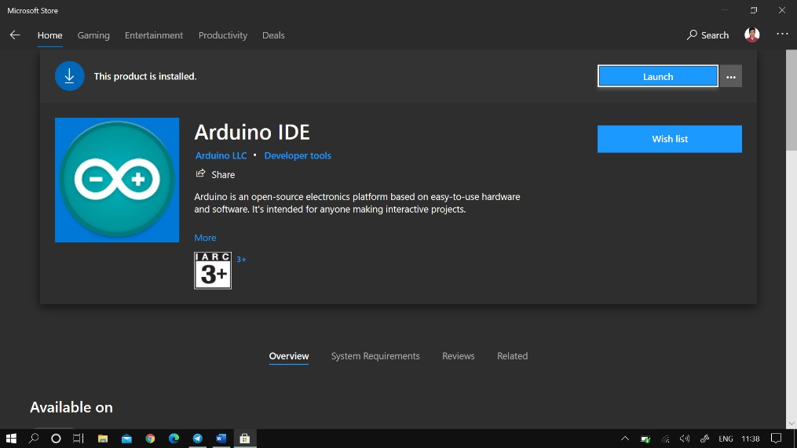

* + - After installing software and connecting the Arduino we must connect the pulse sensor to the Arduino Pins. A diagram is showing below about how the interfacing should be done.

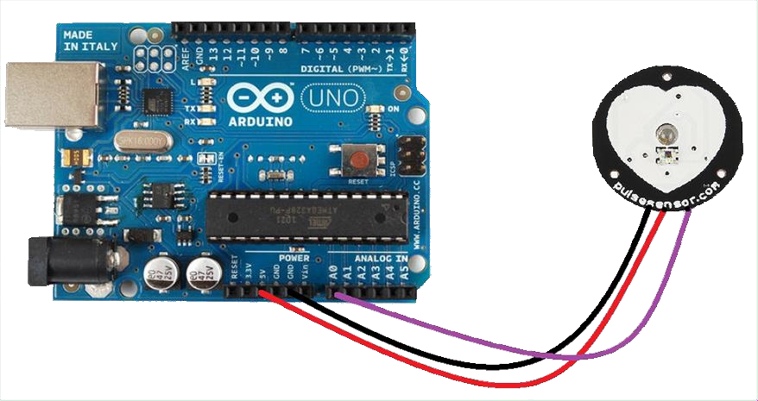

**DEPARTMENT OF CSE, KLEF**

29

* + - Now we must connect the Arduino Uno to a Wi-Fi module to transmit the data which we receive from the pulse sensor to the cloud. Here we used BOLT IOT Wi-Fi module.

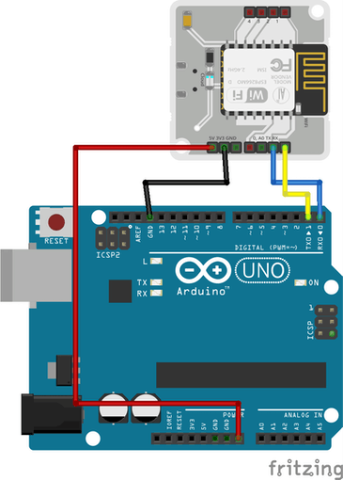

* + - After interfacing is done, we have to write a code to calculate the pulse value from the sensor when a finger is placed on it. The code is given below

## Code:

#include<SoftwareSerial.h> int pin=0;

int led=13; int signal;

int threshold=550; int S;

SoftwareSerial mySerial(10, 11); void setup()

{

pinMode(led,OUTPUT); Serial.begin(9600); mySerial.begin(9600);

}

void loop()

{

signal = analogRead(pin);

**DEPARTMENT OF CSE, KLEF**

30

S=(signal/8)-64; Serial.print("your heart beat is : "); Serial.print(S); Serial.println("BPM”); mySerial.println(S);

if(signal > threshold)

{

digitalWrite(led,HIGH);

}

else

{

digitalWrite(led,LOW);

}

delay(1000);

}

## – Connecting the Hardware setup to AWS VPC

* + - Create an AWS Educate account to create and run an AWS VPS.

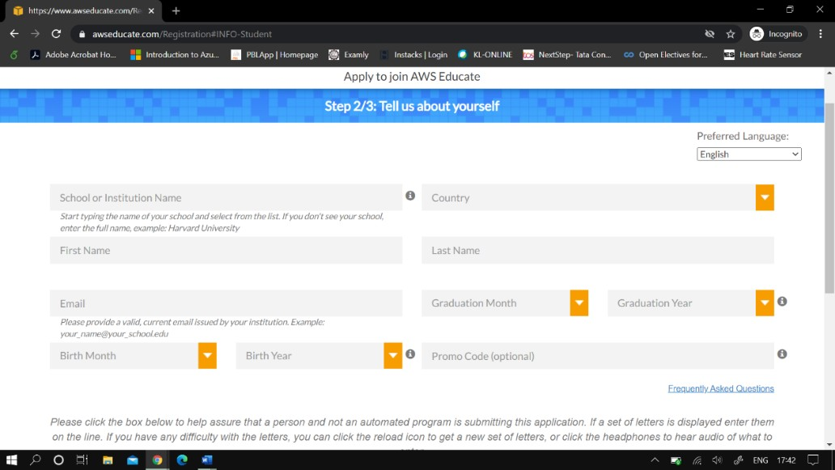

**DEPARTMENT OF CSE, KLEF**

31

* + - After creating the account login to the AWS Educate environment and click on AWS Console.

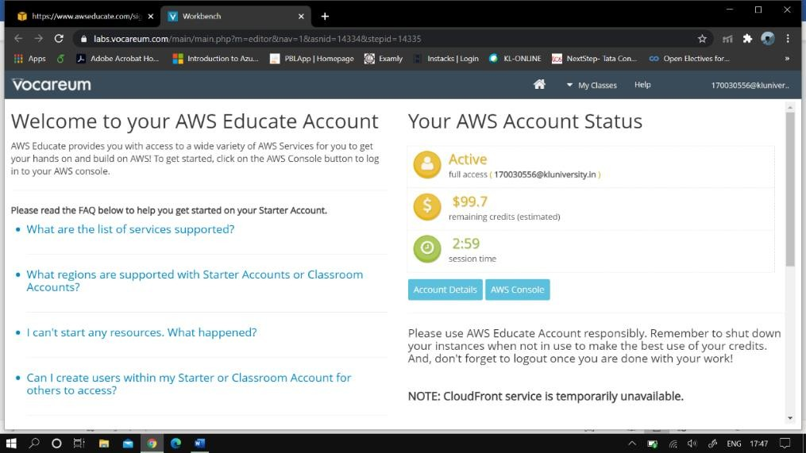

* + - After opening AWS Console. From the services present their search and select launch a virtual machine with EC2.

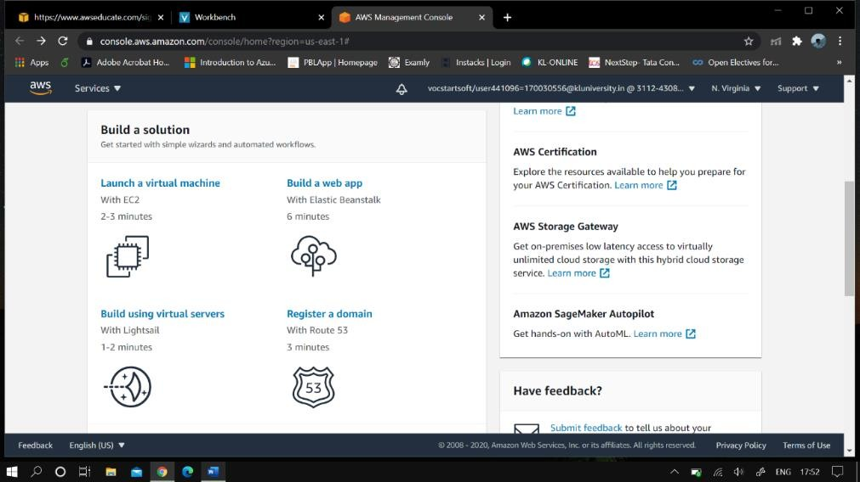

**DEPARTMENT OF CSE, KLEF**

32

* + - Now, select Linux server from all the options available and select all the requirements of your virtual private Linux server.(ex- Instance Type, Storage, Security,etc) and select Review and Launch. Your Linux server will be launched. Here a key will be generated which will be used to connect to the server later.

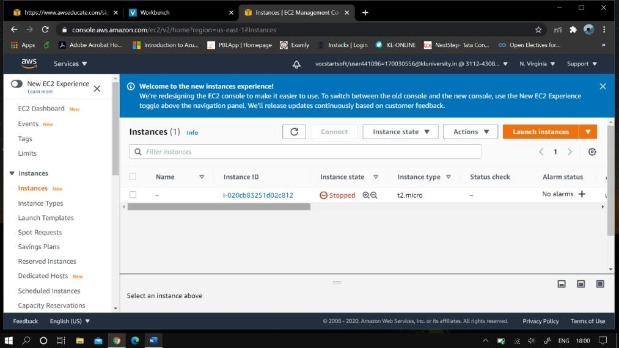

* + - After the instance is launched. Click on the new instance id and select connect various details regarding connection process are displayed.

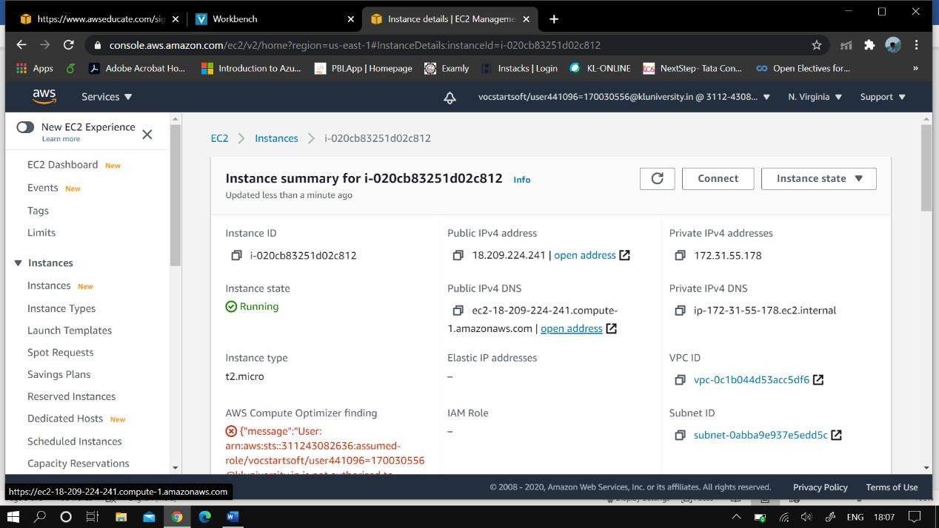

**DEPARTMENT OF CSE, KLEF**

33

* + - After clicking the connect the following details are displayed go to SSH client.

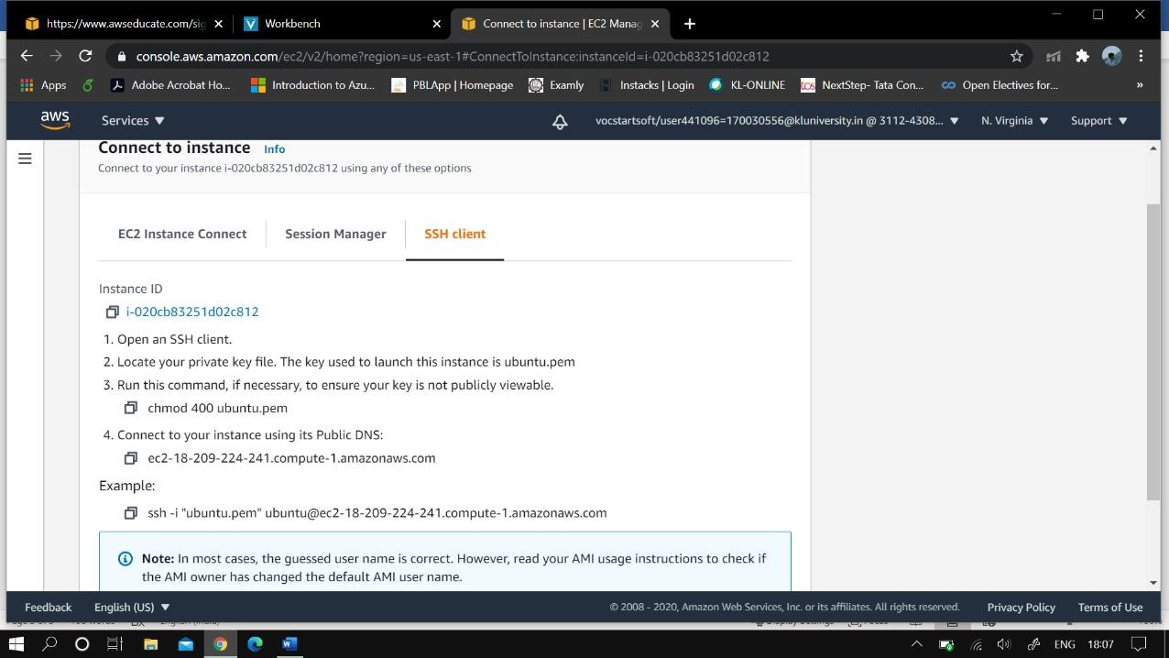

* + - Now by using Putty we must connect to the server we created in AWS. Firstly using the PuttyGen we convert the .pem key which we get from AWS to connect to Putty to a .ppk file which can be used by Putty to connect to the server.

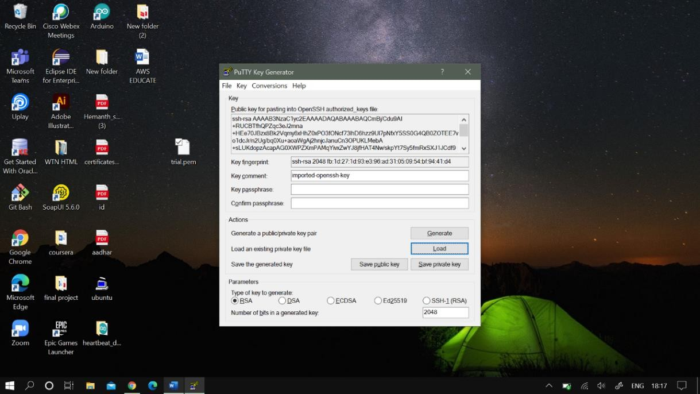

**DEPARTMENT OF CSE, KLEF**

34

* + - Now open putty and select the .ppk key which we converted by using PuttyGen. From the AWS Connect window select Hostname of the instance which we create. Now in Putty go to Connection -> Data and copy paste the username to Auto-login username.

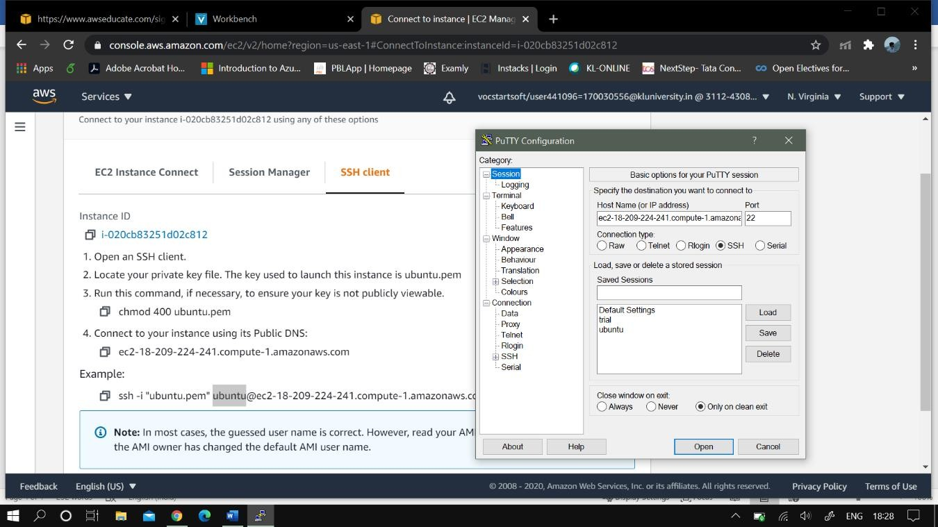

* + - Go to SSH -> Auth in Putty and upload the converted putty key file into the private key file authentication which is present in Putty.

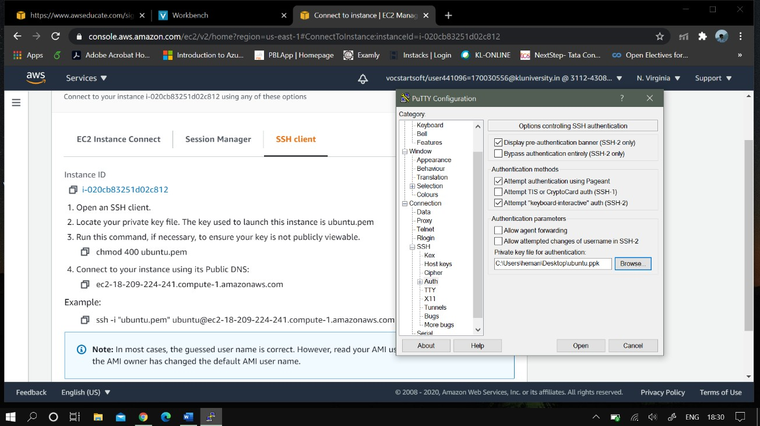

* + - Now go to Session and Click on Open. You will be connected to the linux server to the which is present in AWS.

**DEPARTMENT OF CSE, KLEF**

35

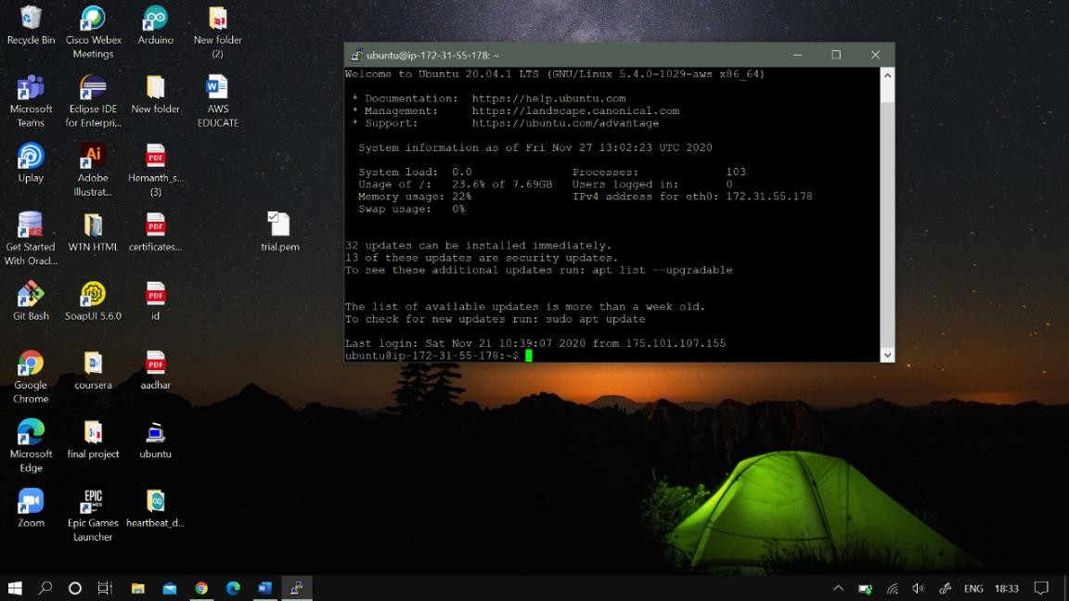

* + - The Linux server is created and configured now we can use this Linux server for the execution of the project.

## – SETTING UP OF TWILIO FOR SMS

* + - Create a Twilio account

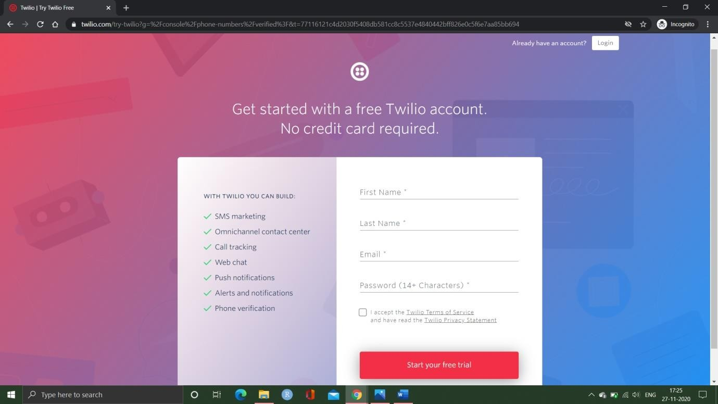

**DEPARTMENT OF CSE, KLEF**

36

* + - Get a trail number to send the messages to participants

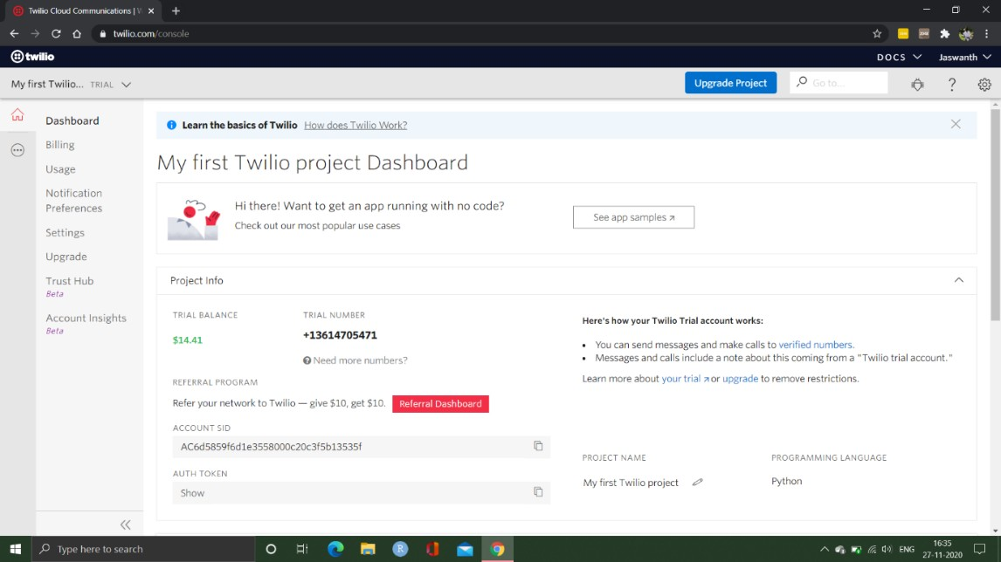

* + - On the left side menu click on phone numbers and you can see the active numbers and if you want to add participants number you should click on verified caller id from left side menu

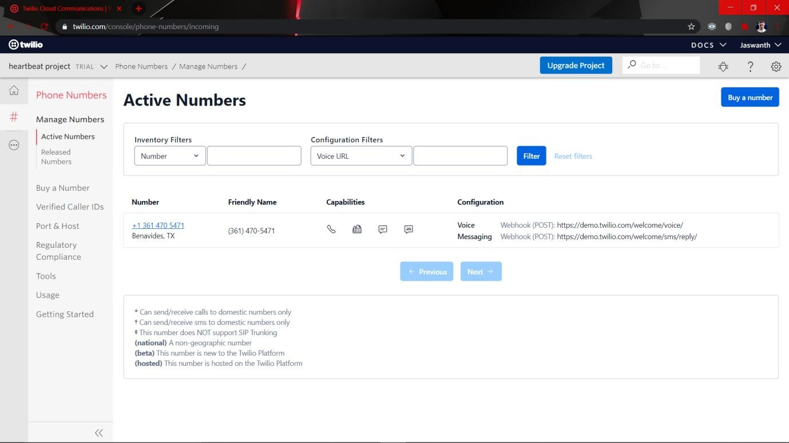

* + - On the top corner u can see the plus (+) symbol icon. Click on it to add the numbers and verify the number by an OTP.

**DEPARTMENT OF CSE, KLEF**

37

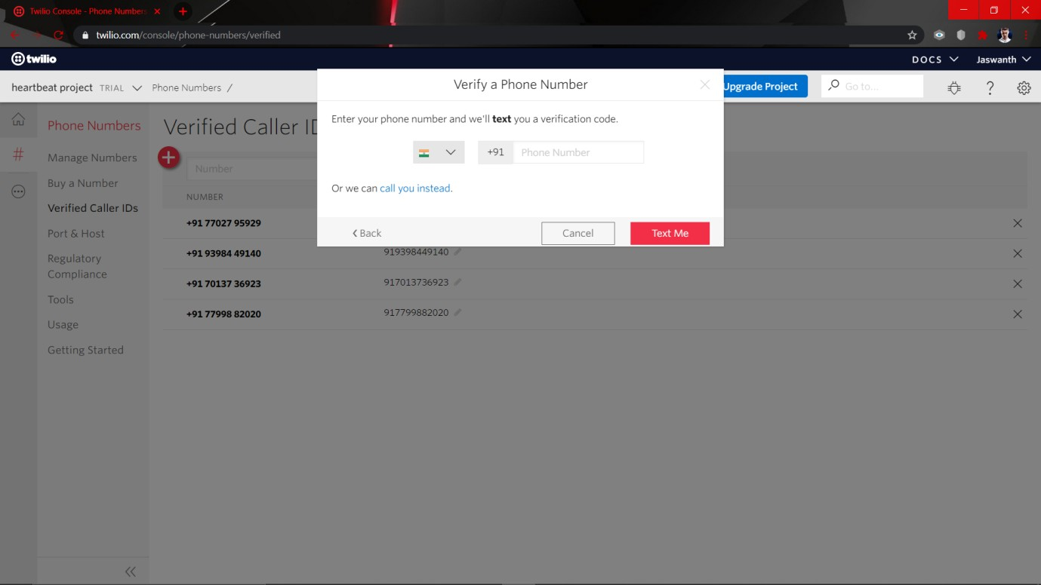

* + - Collected mobile numbers of people whom you want to send the sms(if there is abnormality) is shown here and add the numbers in verified caller id’s as shown

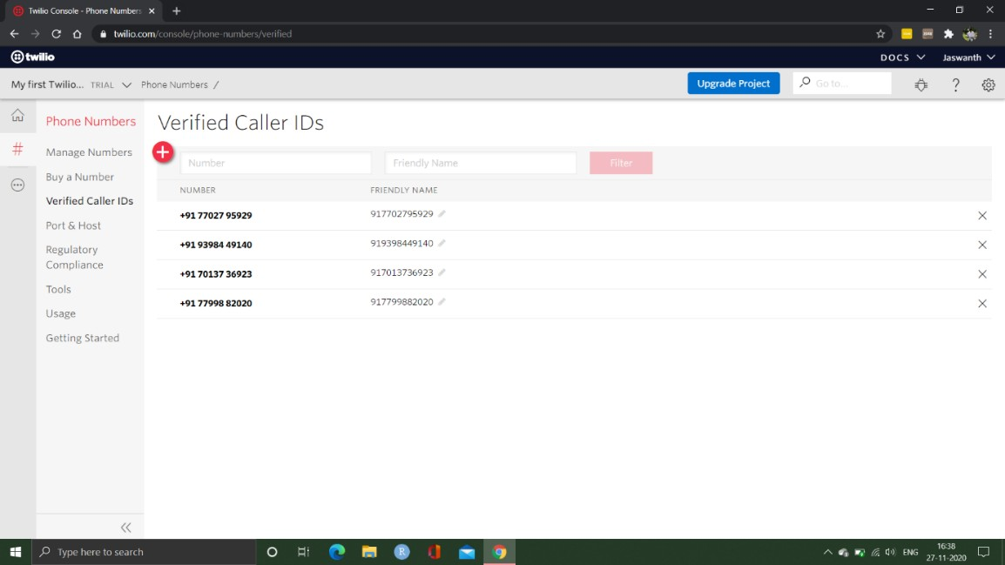

* + - Go to API explorer and select programable messaging from drop down menu and click on messages

**DEPARTMENT OF CSE, KLEF**

38

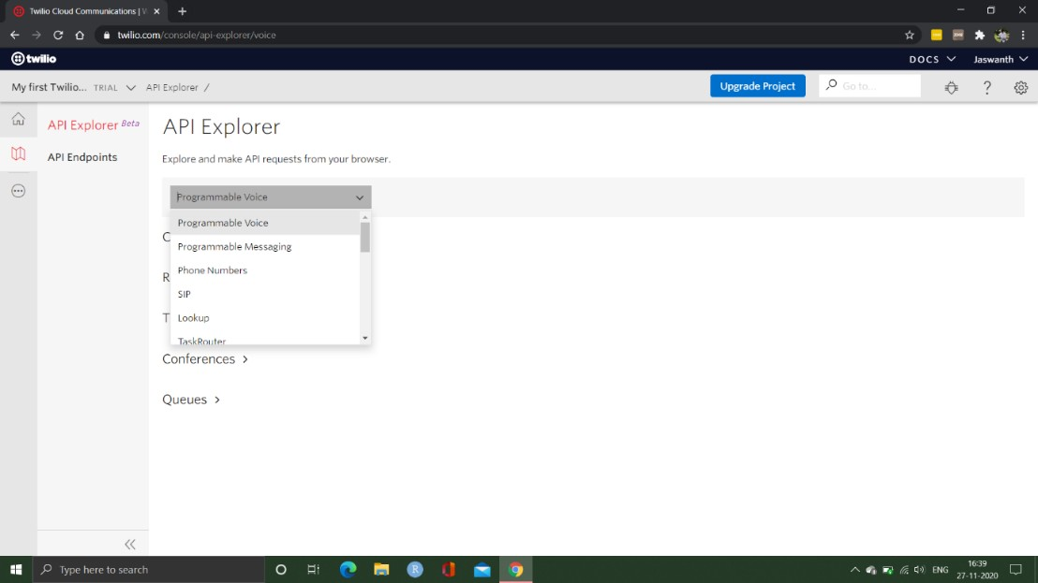

* + - After clicking on messages, you can see various options to create, delete, view and modifying messages

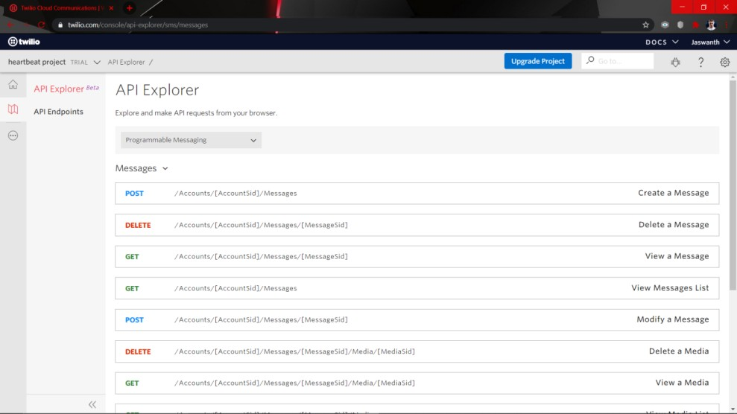

* + - 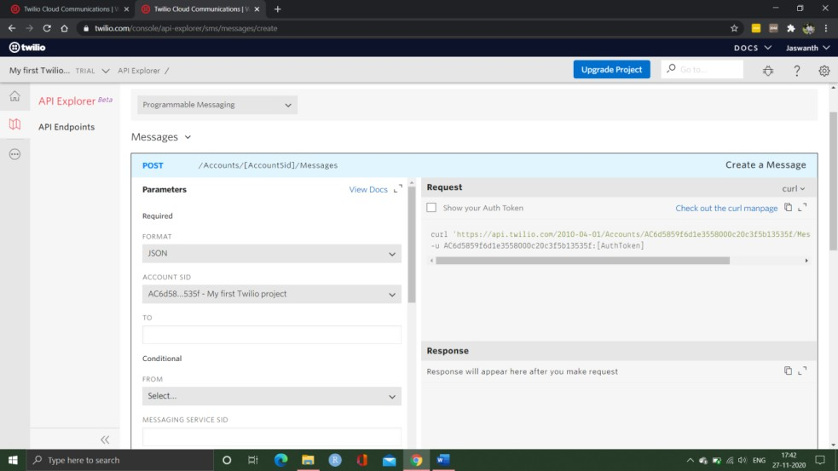Click on create message

**DEPARTMENT OF CSE, KLEF**

39

* + - After selecting the create message

1. Enter the mobile number of participants to whom you are sending the message
2. Click on from drop box and select the trail number which we have created in step 2
3. In the body dialogue box enter the message you are willing to convey
4. Click on make request.

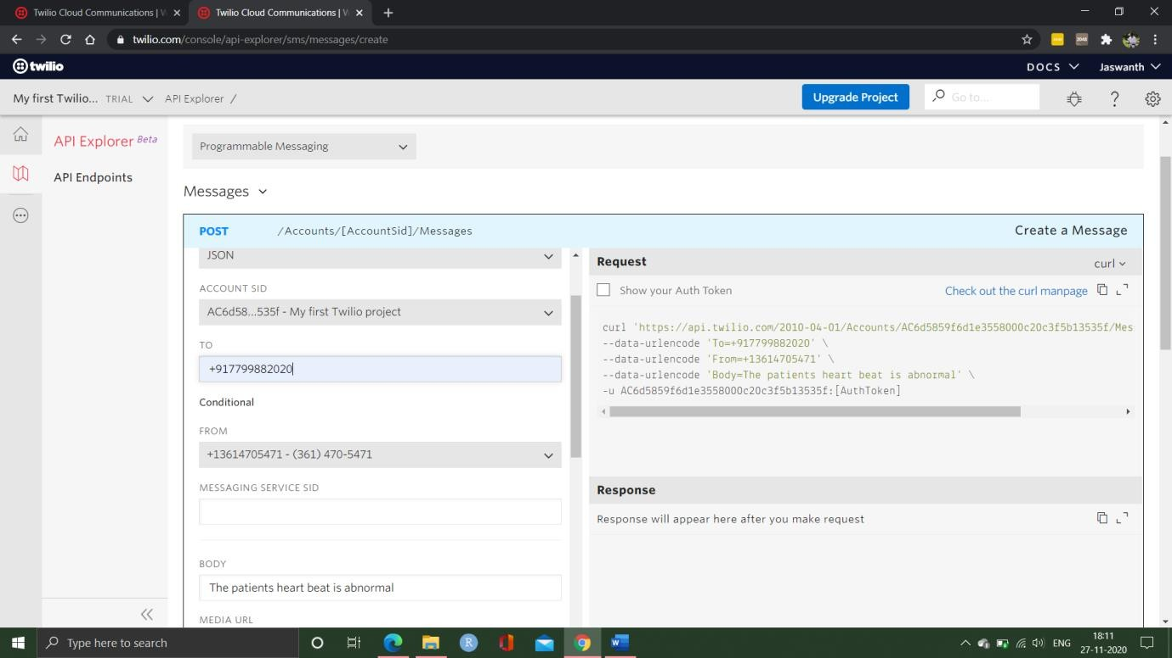

* After clicking on make request it will send the message to particular participant and will generate an account SID and auth token.

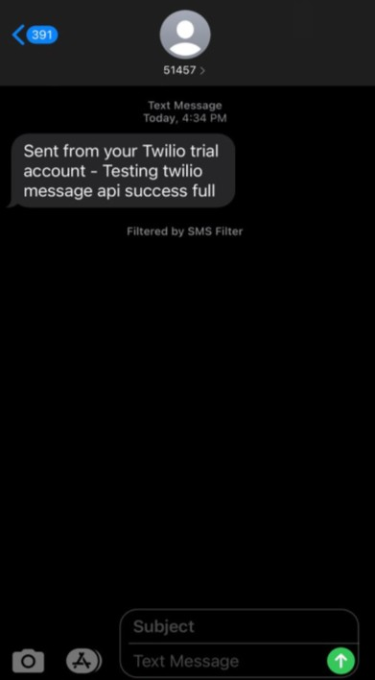

**DEPARTMENT OF CSE, KLEF**

40

* We should save the account SID and auth token

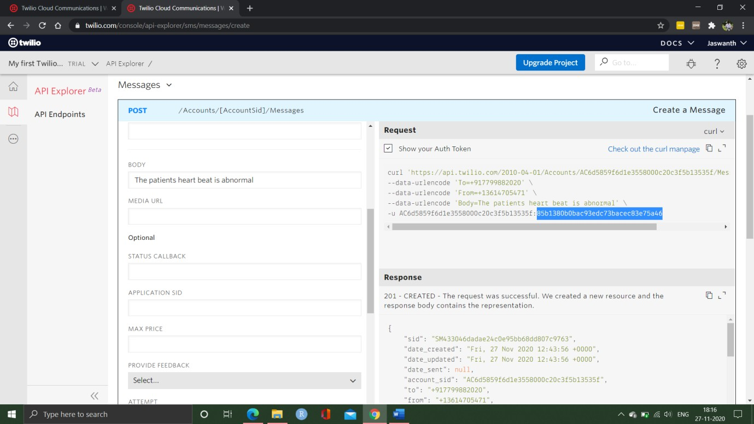

* Now we have to send this saved data to the AWS console.

## – CODING IN AWS FOR CHECKING ABNORMALITY

* + - First launch the instance and connect using putty. After connecting we import the packages which are required by the project the commands which are used are:

sudo apt-get-y update

sudo apt install python3-pip sudo pip3 install boltiot

* + - After installation we must create two files one conf.py and other heart_rate.py in the aws vpc

sudo nano conf.py //file 1

sudo nano heart_rate.py //file 2

## CONF.PY CODE:

#Credentials from Twilio

SID = SM2a4ab3f341c9462d9fe577b316e4aef5 AUTH_TOKEN = 85b1380b0bac93edc73bacec83e75a46 FROM_NUMBER = +13614705471

TO_NUMBER = +917702795929

#Credentials from Bolt

API_KEY = b8085155-c8b8-481d-84c2-9d8d95e6c5b9 DEVICE_ID = BOLT13168670

**DEPARTMENT OF CSE, KLEF**

41

## HEART_RATE.PY CODE:

import conf, json, time

from boltiot import Sms, Bolt

minlimit = 67 #the minimum threshold of heart rate max_limit = 110 #the maximum threshold of heart rate Mybolt = Bolt(conf.API_KEY, conf.DEVICE_ID)

SMS = Sms(conf.SID, conf.AUTH_TOKEN, conf.TO_NUMBER, conf.FROM_NUMBER)

while True:

response = Mybolt.analogRead('A0') data = json.loads(response)

value1 = int(data['value']) value1 = value1

print ("The current Heartbeat of patient is "+ str(value1)+" BPM”) sensor_value=0

try:

sensor_value = int(data['value']) except e:

print("There was an error while sending the response: ",e) continue

try:

if sensor_value > max_limit or sensor_value < min_limit: print ("The heartbeat is abnormal sending SMS")

response = SMS.send_sms("HeartBeat abnormal. The Current heartbeat is " + str(value1)+ " BPM")

print("This is the response for SMS ",response) except Exception as e:

print ("Error",e) time.sleep(10)

* + - Now we have all we need to execute our project run the code which is present in Arduino IDE software and come to putty and type the below command to execute the project.

sudo python3 heart_rate.py //running code

**DEPARTMENT OF CSE, KLEF**

42

# EXPERIMENTAL RESULTS

## – Arduino Output

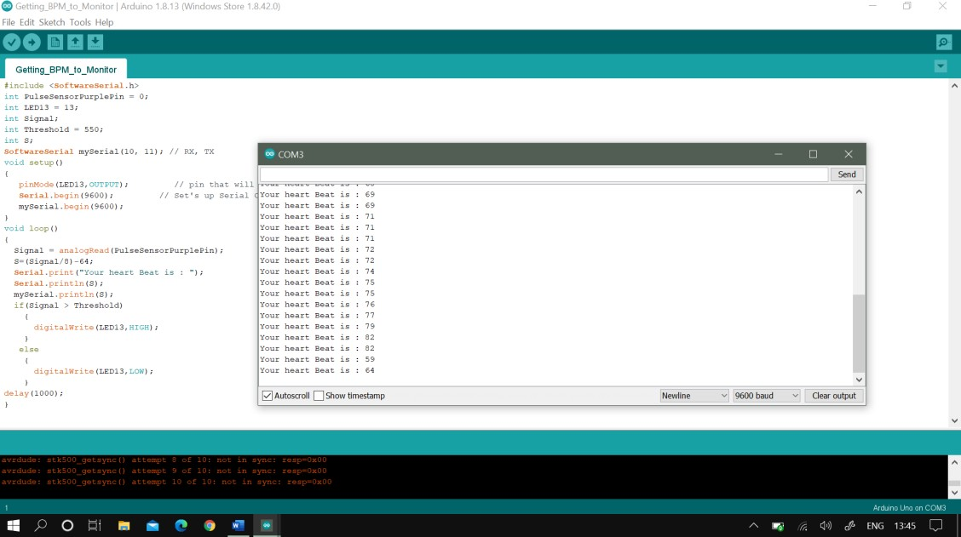

* 1. **– Execution in AWS VPS**

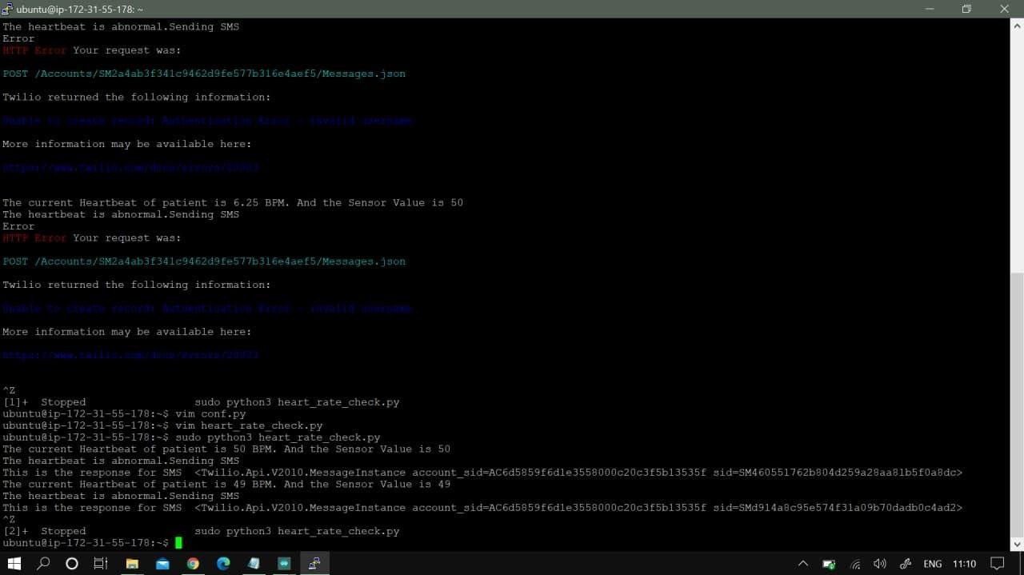

**DEPARTMENT OF CSE, KLEF**

43

## – Twilio Execution

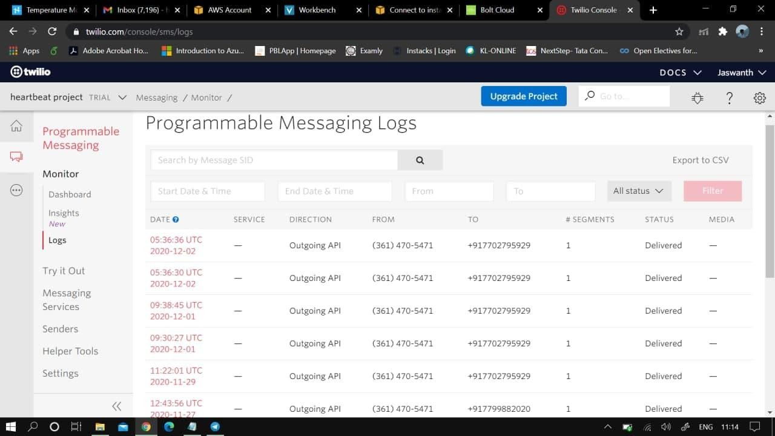

* 1. **– Output received by Client**

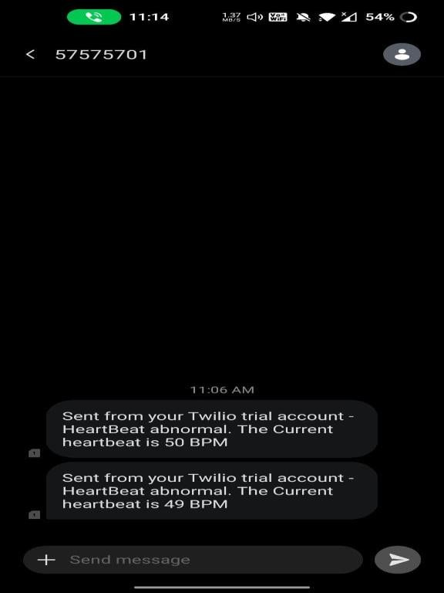

**DEPARTMENT OF CSE, KLEF**

44

# DISCUSSION OF RESULTS

## – ARDUINO OUTPUT

* + 1. In this figure we identify that a person is placed the finger in the sensor and it measures the blood flow of a person.
    2. The blood flow which is detected by using the heartbeat sensor and it is a continuous process as we can see in fig 6.1.
    3. By using the Wi-Fi module which it is connected to the Arduino board and pass the data to the amazon VPS.
    4. The data which is collected from the heartbeat sensor passed to the amazon VPS(virtual private server).

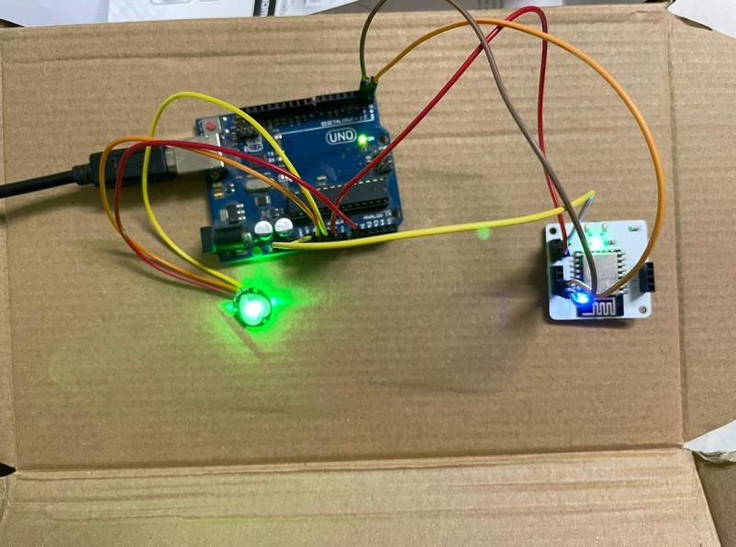

## – EXECUTION IN AWS VPS

* + 1. In this Fig-6.2 the data which is collected from the Arduino board and it checks the patient heartbeat pass the data to the VPS.
    2. The heartbeat sensor which it collects the data from the patient and continuously check if there is abnormality in patient’s data.
    3. If the patient abnormality is below 64 or above 110 automatically the virtual private server sends the message to the Twilio and Mailgun.
    4. So that the virtual private service will automatically follow up the patient’s data to the Twilio and the Mailgun services.

**DEPARTMENT OF CSE, KLEF**

45

## – TWILIO EXECUTION

* + 1. In this Automation services an API key generated which it is placed in the code and get a connection between the virtual private service and Twilio services.
    2. In this service we must collect the patients phone numbers and the doctors phone numbers are saved in the Twilio monitor dashboard.
    3. In this service if the patient abnormality is less than 64 and greater than 110 it delivers the message to the patient and doctors mobile.
    4. The Twilio service sends the message like the patient abnormality is less and meet a consultant doctor and the doctors phone number will be send to the patient.
    5. As we can see in fig 6.3 it also displays the status of the message whether it is delivered or not.

## – OUTPUT RECEIVED BY CLIENT

* + 1. The message is received from the Twilio which it shows that the patient condition is not in normal condition.
    2. It also displays the abnormal heartbeat of the patient and the patient so the doctor can check upon the patient as soon as possible. (Fig- 6.4)

**DEPARTMENT OF CSE, KLEF**

46

# CONCLUSION

This covid-19 pandemic has caused many problems to everyone and especially the most

affected ones are the patients. Patients whose heart pulse needs to be monitored regularly by the concerned doctors are affected by this Covid-19 outbreak. There has been a communication gap formed between these patients their concerned doctors/caretakers. Due to the implementation of lockdown all over the world, the situation got worse for the patients.

This is where our idea flourished to help those section of patients whose heart pulse needs to be monitored regularly. With the help of the knowledge we gained from the concepts of IOT and its applications in medical field, we have researched and studied many research papers related to our problem statement. After reviewing many papers, finally we have chosen one paper as our base paper and started working on the idea. Our project “Heart Pulse Detection and Notification System using Arduino” mainly focuses on the communication gap between the patients and their doctors. The main aim of our project is to establish a communication bridge between the patients and the concerned well takers/doctors. We have used reliable components such as Arduino uno, which is the brains of our system, KY039

heart pulse sensor, which detects the heart pulse of the body, and BOLT Wi-Fi module for establishing a connection to send data through the internet. We have used the most reliable VPS service provider which is the AWS VPS to run the program(code) required to detect the abnormality present in the heart pulse. For the notification module, we have used TWILIO as our online API service which sends data to the concerned doctor whenever there is an abnormality present in the patient’s heart pulse.

**DEPARTMENT OF CSE, KLEF**

47

# USER STORIES

1. As a developer of this project, I will do my best to provide users of this project a simple, seamless and an automated experience.so that the users of the project will not have any trouble using it.
2. As a patient, I should be able to view my readings and I should receive immediate assistance. So that if there is any emergency the doctor should come to know about this, and I should receive assistance immediately.
3. As a doctor, I should be able to monitor my patients without any interruption and should be notified immediately if there is any anomaly in my patients’ statistics. So that I provide my assistance to the patient.

# MOTIVATION AND FUTURE SCOPE

1. With the help of our guide, we could able to understand the overview of our project and how to distribute the tasks among ourselves.
2. By the end of our project, we as a team are confident that we all shall complete the project in given time and also make sure the project is available and reliable to the users( especially patients).
3. Future Scope of our project is to create an webpage so that the data collected through the sensor is displayed on a webpage and also stored in database.
4. The extended part of our project is to create separate modules in a website for end users , doctors and patients. By these modules, the respective users can access their previous records stored in the database.

**DEPARTMENT OF CSE, KLEF**

48

# REFERENCES

1. Remote Patients Monitoring System(Heartbeat and Temperature) using Arduino,Ruaa Shallal Abbas Anooz, Methodology -using IOT,IJSER,Volume 9,ISSN 2229-5518, August 2018.

Reference link- [www.researchgate.net/publication/330666824](http://www.researchgate.net/publication/330666824)

1. Internet of Things for Smart HealthCare: Technologies, Challenges, and Opportunites, Stephanie B. Baker , Wei Xiang , Ian Atkinson,IEEE Access, Volume-5, doi; 10.1109/ACCESS.2017.2775180, November 2017.

Reference link - <https://ieeexplore.ieee.org/document/8124196>

1. A study on cloud based Internet of Things: CloudIoT[,Shaik Masthan Babu;](https://ieeexplore.ieee.org/author/37085633865) [A. Jaya Lakshmi;](https://ieeexplore.ieee.org/author/38238301600) [B. Thirumala Rao,](https://ieeexplore.ieee.org/author/37085652014) 03 December 2015.

Reference link - <https://ieeexplore.ieee.org/document/7342624>

1. On the Integration of Cloud Computing and Internet of Things, [Alessio Botta;](https://ieeexplore.ieee.org/author/37298860900) [Walter de Donato;](https://ieeexplore.ieee.org/author/37400261300) [Valerio Persico;](https://ieeexplore.ieee.org/author/37085523275) [Antonio Pescapé,](https://ieeexplore.ieee.org/author/37272996300) 15 December 2014.

Reference link - <https://ieeexplore.ieee.org/document/6984170>

1. Heartbeat Monitoring Using IoT, Sayan Banerjee; Souptik Paul; Rohan Sharma; Abhishek Brahma, 17 January 2019.

Reference link- <https://ieeexplore.ieee.org/document/8614921>

1. Analysis of Heart Rate and Body Temperature from the wireless monitoring system using Arduino,Mohammad Dabbagh. Methodology – using IOT. Published – Nov2019

Reference link- [www.researchgate.net/publication/337116465](http://www.researchgate.net/publication/337116465)

1. Continuous Heart Rate and Body Temperature Monitoring System using Arduino UNO And android device, Asaduzzaman Miah, Hussain Kabir,Siddiqur Rahman Tanveer ,M.A.H. Akhand. Methodology – using IOT. Published – 2015 second International conference on electrical information and communication technologies.

Reference link- <https://ieeexplore.ieee.org/document/739194>

1. Developing IOT Based Smart Health Monitoring Systems: A Review, Ashikur Rahaman, Muhammad Sheikh Sadi, Sheikh Nooruddin. Methodology – using IOT.published-september2019,

Reference link- [www.iieta.org/journals/ria/paper/10.18280/ria.330605](http://www.iieta.org/journals/ria/paper/10.18280/ria.330605)

1. Smart Healthcare Monitoring using IOT, ShubhamBanka, Isha Madan and S.S. Saranya. Methodology – using IOT. Published – January 2017. Reference link- <https://www.ripublication.com/ijaer18/ijaerv13n15_40.pdf>
2. Development of smart health care monitoring system in IoT environment, Md.Milon Islam, Ashikur rahaman, Md.rashedul Islam. Methodology – using IOT.published- May2020.

Reference link - <https://link.springer.com/article/10.1007/s42979-020-00195-y>

**DEPARTMENT OF CSE, KLEF**

49

1. Low cost Heart rate Portable Device for the Risk patients with IOT and warning system,Muhammad Irman, Era Madon. Methodology-using IOT, published-June 2018 Reference link - <https://ieeexplore.ieee.org/document/8686761>
2. An IoT-Based Smart Framework for Human Heartbeat Rate Monitoring and Control System,Sani abba, Abubakar Mohammed garba. Methodology -using IOT.published- November 2019

Reference link - [www.researchgate.net/publication/337275306](http://www.researchgate.net/publication/337275306)

1. IoT Based Heart Activity Monitoring Using Inductive Sensors, Adrian Brezulianu, Oana Geman. Methodology-using IOT, Published-26 july 2019.

Reference link- <https://www.mdpi.com/1424-8220/19/15/3284>

1. A smart system for remote monitoring of patients and SMS messaging upon critical Condition Angad Kale, Siddharth.K. Kaul, Debi Prasad Das and S. Raghunath. Methodology-using IOT, published-2007

Reference link - <https://ieeexplore.ieee.org/abstract/document/4475765>

1. Web-based remote monitoring of infant incubators in the ICU,D.I. Shina, S.J. Huha,

T.S. Lee , I.Y. Kimc. Methodology-using IOT, Published-September-2003 Reference link -

<https://www.sciencedirect.com/science/article/abs/pii/S1386505603000959?via%3Dihub>

**DEPARTMENT OF CSE, KLEF**

50



The Report is Generated by DrillBit Plagiarism Detection Software

***Submission Information***

|  |  |
| --- | --- |
| Author Name | kavitha |
| Title | Asst.profeessor |
| Submission/Paper ID | 194951 |
| Submission Date | 11-Dec-2020 04:07:57 |
| Total Pages | 50 |
| Total Words | 8651 |

***Result Information***

|  |  |
| --- | --- |
| Similarity | 16 % |
| Unique | 84 % |
| Internet Sources | 6 % |
| Journal/Publication Sources | 8 % |
| Student papers | 1 % |
| Total content under 'Quotes' | 16 % |

***Exclude Information***

|  |  |
| --- | --- |
| References/Bibliography | Not Excluded |
| Quotes | Not Excluded |
| Sources: Less than 14 Words Similarity | Not Excluded |